MRU | Department of Computer Science & Technology, MRU, Faridabad
MRU | Lab Assignment 3: GUI using Swings
Subject: Advance Java Workshop Subject Code: CSW308B Semester: V

Objectives

- To design GUI using Swing basic components.

CO1 ,CO2

- Design a student registration form using swings.
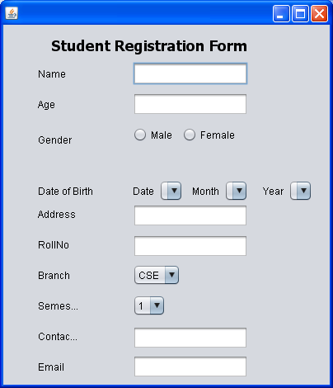
- Design login form given below :
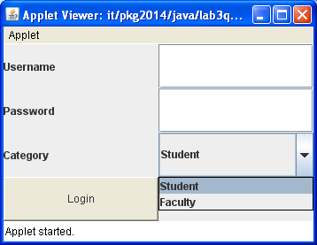
- Create GUI shown below :
